2)
import java.util.Arrays;

public class Main
{
private static int[] mergeArray(int[] array1, int[] array2)
{
System.out.println("E.pavan kumar reddy\n51834760");
int[] mergedArray = new int[array1.length + array2.length];

int a=0, b=0, c=0;

while (a < array1.length)
{
mergedArray[c] = array1[a];
a++;
c++;
}

while (b < array2.length)
{
mergedArray[c] = array2[b];
b++;
c++;
}

Arrays.sort(mergedArray);

return mergedArray;
}

public static void main(String[] args)
{
int[] array1 = new int[] {1,2,3,6,8,6,2,9};

int[] array2 = new int[] {25,-45,74,-52,-8,89};

int[] mergedArray = mergeArray(array1, array2);

System.out.println("input:\n "+Arrays.toString(array1));

System.out.println(Arrays.toString(array2));

System.out.println("output: "+Arrays.toString(mergedArray));
}
}

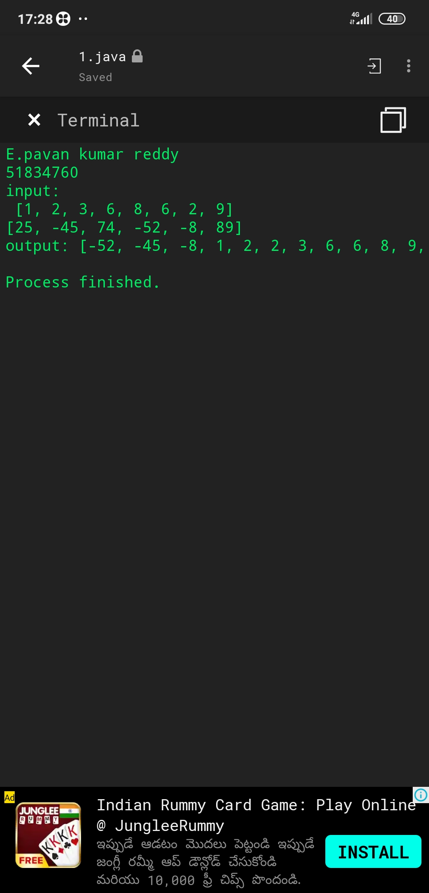

3)
import java.util.*;
interface Student{
abstract public void name();
abstract public void clas();
abstract public void age();
}
class Your_name implements Student{
public void name(){
System.out.println("iam pavan");
}
public void clas(){
System.out.println("iam stufying 6th");
}
public void age(){
System.out.println("my age is 18");
}

public static void main(String[] args){
Your_name o=new Your_name();
System.out.println("E.pavan kumar reddy\n51834760");
o.name();
o.clas();
o.age();
}
}
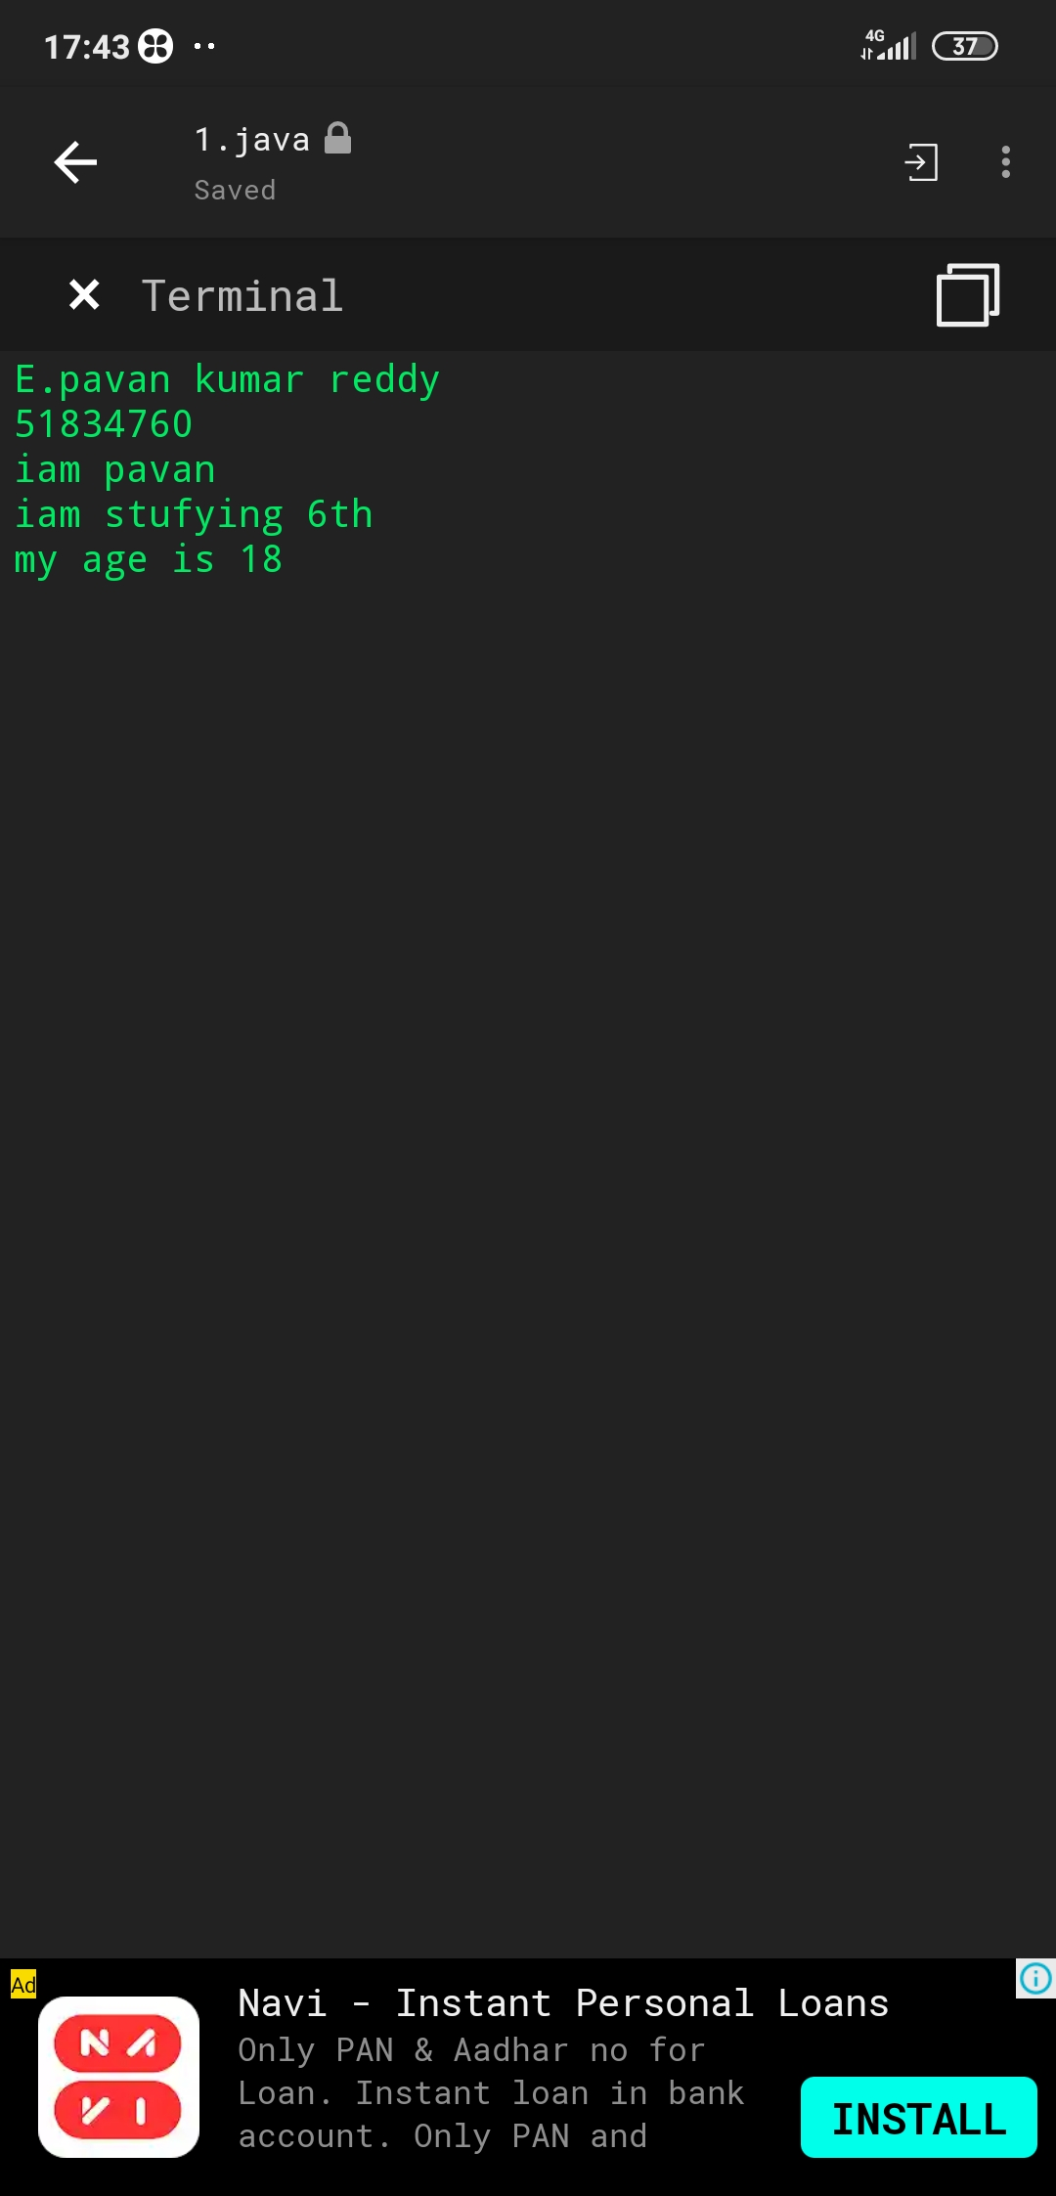

5)
import java.util.Scanner;

public class Pavan
{

public static void main(String args[])
{
System.out.println("E.pavan kumar reddy\n51834760");
System.out.println("input: ");

Scanner sc = new Scanner(System.in);

String a = sc.nextLine();

int count = 1;

for (int x = 0; x < a.length() - 1; x++)
{
if ((a.charAt(x) == ' ') && (a.charAt(x + 1) != ' '))
{
count++;

}
}

System.out.println("output " + count);
}
}
